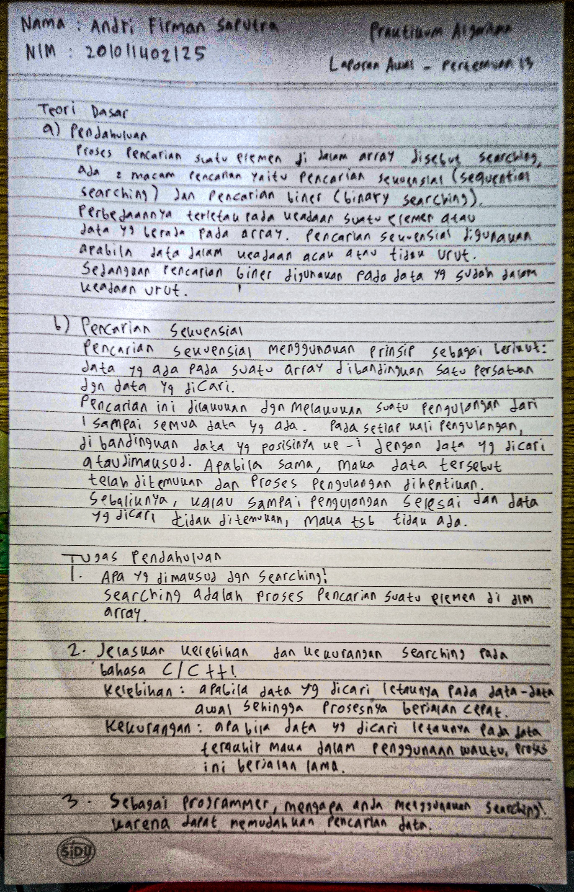

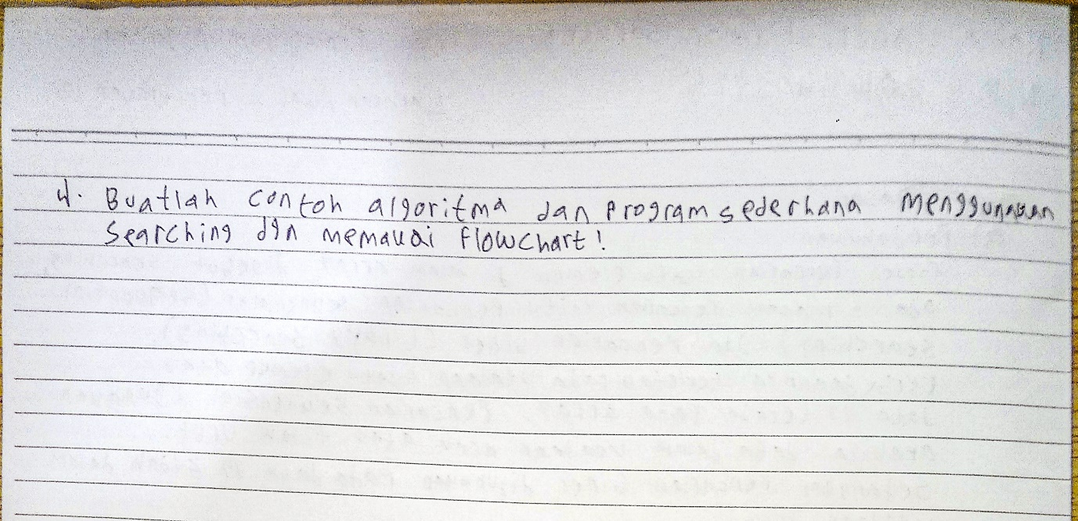

**Jawaban No. 4**

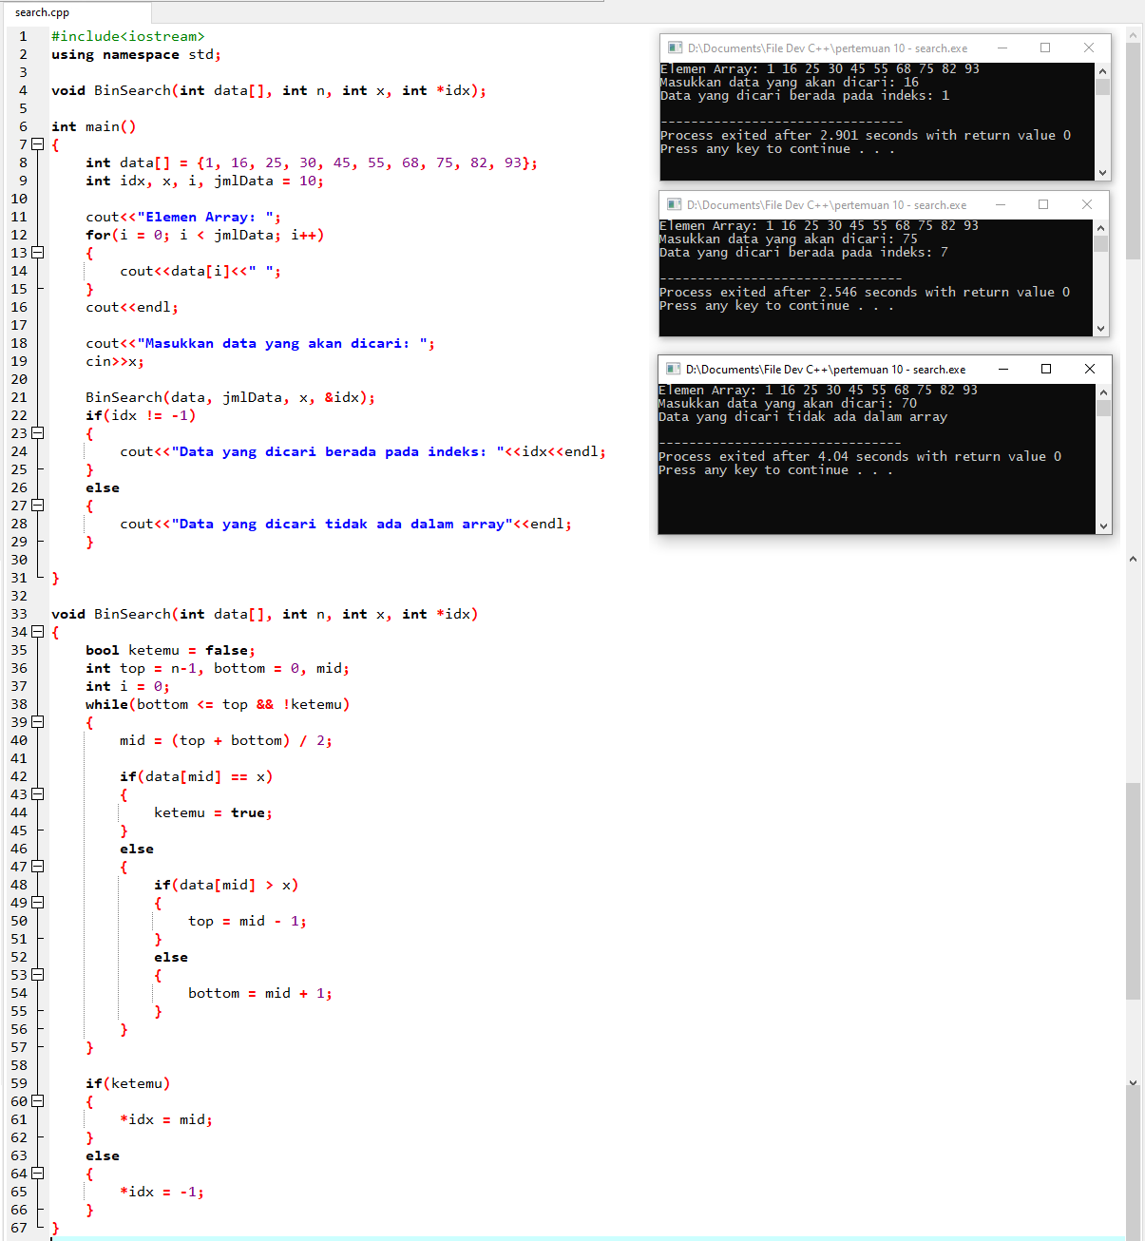

**Source Code:**

#include<iostream>

using namespace std;

void BinSearch(int data[], int n, int x, int *idx);

int main()

{

int data[] = {1, 16, 25, 30, 45, 55, 68, 75, 82, 93};

int idx, x, i, jmlData = 10;

cout<<"Elemen Array: ";

for(i = 0; i < jmlData; i++)

{

cout<<data[i]<<" ";

}

cout<<endl;

cout<<"Masukkan data yang akan dicari: ";

cin>>x;

BinSearch(data, jmlData, x, &idx);

if(idx != -1)

{

cout<<"Data yang dicari berada pada indeks: "<<idx<<endl;

}

else

{

cout<<"Data yang dicari tidak ada dalam array"<<endl;

}

}

void BinSearch(int data[], int n, int x, int *idx)

{

bool ketemu = false;

int top = n-1, bottom = 0, mid;

int i = 0;

while(bottom <= top && !ketemu)

{

mid = (top + bottom) / 2;

if(data[mid] == x)

{

ketemu = true;

}

else

{

if(data[mid] > x)

{

top = mid - 1;

}

else

{

bottom = mid + 1;

}

}

}

if(ketemu)

{

*idx = mid;

}

else

{

*idx = -1;

}

}